User Research Protocol

STAGE 1 | MEET WITH STAKEHOLDERS

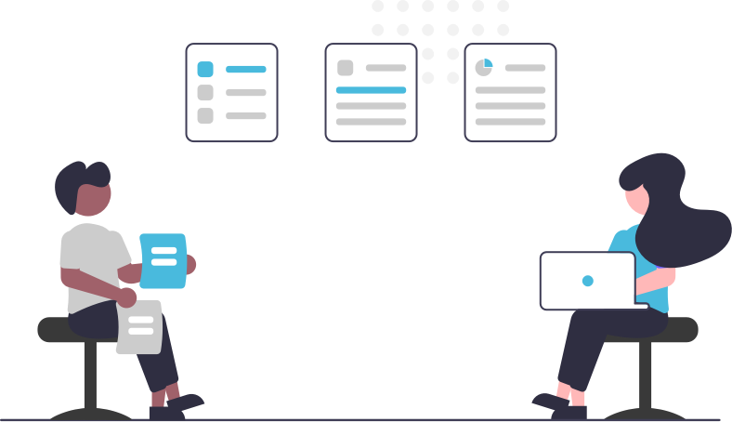
Begin any research project by asking lots of questions for clarity and a shared understanding.
Identify All Stakeholders
- Who wants this research?
- Who has interest in this project?
- Identify all people whose work touches this project.
- Are Stakeholders willing to discuss research findings and discuss insights and next steps?

Research Goals
- What are we researching?
- Why are we researching this?
- What design questions do we have?
- What problem are we hoping to better understand?
- What are the large goals?
- What are the small goals?
- What form of communication is most helpful to the team?
- Is research already available for this topic?
- What will be done with the results?

Relevant Service/Product Information
- Do you know the history of the service/product?
- What is in store for the future?

Users
- Who uses the service/product?
- Has the audience for this product/service changed? Why?
- What kind of user/non-user do we want to study?
- What are participant demographics, location, usage patterns?
Success
- What is the Stakeholder’s idea of success for this service/product?
- What is the team's idea of success?
- Are there ‘money metrics’ to measure by?
- How is this being measured already?
- Are there other studies against which to compare the usability test results?
- What is the team's greatest hope?
- What is the team's greatest fear?

Competitors (Optional)
- Who are the biggest competitors? Why?
- How does this service/product or company compare?
- What are user expectations based on the competition?

Timing and Scope
- What time frame are Stakeholders working with?
- When are findings due?

STAGE 2 | DEVELOP A RESEARCH PLAN

Start at the End
Identify feedback meaningful to Stakeholders for maximum impact
- Key Themes
- Verbal or Video Participant Responses
- Rating Scales
- Task Completion rates
- Task Success Measurements
- Annotated app interfaces
- Short summary report with an accompanying video

Are there measurements that were not considered or discussed but which may help Stakeholders make decisions? Consider including these in the test plan with annotations explaining why they were included.

Consider at least three research types to answer Stakeholder questions, from simple to complex, fast to time consuming, and cheap to expensive. When to Use Which Research Methods by Christian Rohrer is an excellent source with several dimensions by which to identify research outcomes. Some common research methods:
- Live Interviews, remote or in-person. See Appendix for example Usability Test Plan.
- Unmoderated testing like UsabilityHub
- Card sort or tree test. Optimal Workshop is a trusted provider with excellent analytics.
- Co-Creation activities, such as Gamestorming or Innovation Games

When a research approach is determined, share the research plan with Stakeholders to confirm that research findings will result in useful feedback and insights. Revise research as needed.

STAGE 3 | ENLISTING AND SCHEDULING PARTICIPANTS

Choose participants that match the demographic determined in the Stakeholder meetings. Schedule live interviews at a time when Stakeholders and other team members can attend.

Finding Participants
- Participant Recruitment Services
- Social Media
- Craig’s List
- Forums
- Customer Support calls
- Live Intercept
- Friends and Family
- Coffee shop Guerilla Approach
- Professional Networks
- University Campus
- Local church(es)
- Local school(s)

Write an enlistment screener survey. Choose the best-qualified participants for your study from the respondents of the screener survey.

Scheduling
Scheduling services allow participants to schedule live interviews at times you predetermine. Unmoderated research does not need participant scheduling.

Communicate timelines and dates for live interviews to all Stakeholders and other team members.

LIVE INTERVIEWS SCHEDULING TIMELINE

Up to a Week Before
- Send qualified participants an email explaining they have been chosen to participate in a research study with the date and time of their appointment.
- Ask participants to respond to the email to confirm their participation. See Appendix for email templates.
- invite all designated observers. Attach or provide a link to notetaking forms and a link to the calendar invitation. Explain that observers will stay in the meeting for an additional 30 minutes to debrief with the research team.
- If there are many on-site observers, consider scheduling a conference room for all observers to watch the live interview and debrief in one location.
- Schedule Pilot Tests (research rehearsal sessions) with internal participants. Pilot test observers should be members of the Usability Test team or Stakeholders. Make adjustments in the Test Plan, timing, devices, etc., as needed. Pilot Tests may occur any time before the scheduled live interviews.

The Day Before
- Send a reminder email with the date and time of the appointment and if necessary, a link to the remote meeting software to both participants and observers.
- Ask participants to contact you as soon as possible if they are not able to keep the appointment.
- Provide observers a link to the notetaking form, stressing the importance of their observations which they will share during the debrief with the research team.

Live Interview Day
- Send a reminder email and/or text with the date and time of the appointment and a link to the remote meeting software.
- If the team has a regular check-in meeting or specified communication channel, remind them of the live interview.

EXECUTING LIVE INTERVIEWS

Pre-Testing Checks

At least 30 minutes before the Pilot Test make sure to:

- Double check recording software is working.
- Check that audio and video is working.

In-Person Interview Details

- Provide participants with preferred device types, if necessary.
- Provide both a mouse and a keyboard for the participant.
- Have copies of consent forms for in-person participants.
- Remote participants typically verbally consent/not consent before interview.

Always Pilot Test
A Pilot Test is a rehearsal of the research session with anything and everything used during the live research interview such as devices, recording software, forms, questions, etc.
Pilot test with internal participants at least a day before the live interview, which gives the research team time to make adjustments to the test plan, testing environment, etc.

Observers and Note Taking Forms
Again, provide each observer with a form for note taking for each live interview session.
Remind them to:
- Watch for usability issues and patterns of issues.
- Track progress of the test participant.
- Track deviations from the happy path and what lead them astray.
- Do not get so caught up in taking notes that they neglect to observe!
- Identify and describe usability problems.
- Upon finishing the session, write down any further observations and expand on any partial notes taken during the session.

Explain to observers that they will refer to this doc during the debrief and will send it back to you as an artifact of the live interview. As a plus, expecting observers to take notes keeps them engaged.

The note taking document may take several manifestations, but must be sharable by the observer and the text accessible by the researcher.
- Google Doc or Spreadsheet with designations for each observer
- Shared document space, like Confluence
- Google Form or Survey
- Interactive PDF
- Sticky notes (for in-person groups only)

AFTER LIVE INTERVIEWS

Debrief with the Team
After each live interview, leave enough time to debrief with the team. Compile observer notes on a whiteboard or a sharable document. Respect observers and place value on observer notes even if they are futuristic, defense of implementation, user confusion, errors, or missteps. Include all observer notes, on whiteboard or shared document. After the debrief and during analysis, insights will be grouped to identify themes. In this private space with the research team, observations not meaningful to research outcomes can be removed.
Missed Sessions
If a participant misses the session for which they were scheduled, send an e-mail and/or text to see if they would like to reschedule.

Incentives
If incentives are included these should be dispensed at the conclusion of the interview or set of interviews. Incentive ideas:
- Amazon Gift Card
- Coffee Shop Gift Card
- Donation to charity in the user’s name

If sending a gift card, make sure to inform the participants at the end of each interview that the link to their incentive will be sent through their email and give them a time frame to look for the email with the gift card. Provide your contact information to get back with you if they do not receive the gift card.

Post Test-Send Thank You
- Send a follow-up thank you message to participants. Include information requested by the participant, if needed.
- If possible, send this message with the incentive.

STAGE 4 | ANALYZE DATA

After user research is conducted, analysis begins. All user research analysis involves grouping and finding relationships between problems and issues , text analysis, tagging, and coding. Make note of Stakeholder requests for insights. Include the following:
- Major issues
- Severity Scale
- Opportunities for improvement
- Quotes
- Participant questions
- Usability/Strategic/Feature wins
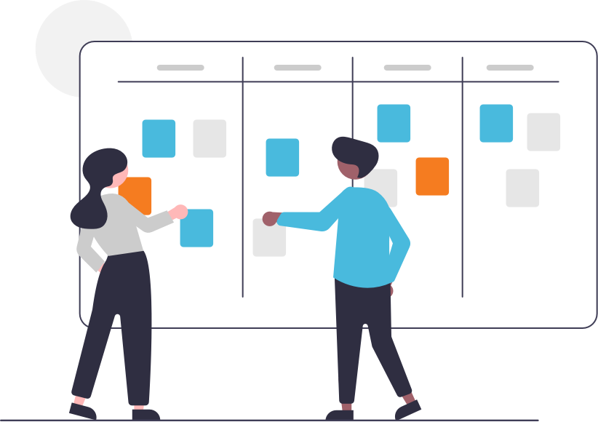

Research Findings
The type of research findings deliverables will depend on the team, Stakeholders, and the research request.
- A few sentences of issues and/or wins
- One page handout with a summary of key findings, conclusions, and opportunities
- Short message in an email, communication forum, or shared document space.
- Charts and graphs, comparing multiple data points.
- Full presentation with PPT and Handout
  - Key Findings
  - Recommendations
  - Research objectives
  - Methods
  - Participants
  - Quotes
  - Video Clips or source notes

Good research findings serve as shared point of understanding to the team. Be a visual storyteller. Include a short table, diagram, or make an infographic. Canva has free resources for creating engaging infographics.

Research Archives
Archive research findings in a shared space, easily accessible for future reference. Archived, accessible research findings confirm long-standing usability issues, and help prioritize story cards for agile teams.

APPENDIX

Consent Forms..………………………………………………….………………….11

Communication Templates…………………………………………………….13

Usability Test Plan………………………………….…………………..….………17

SUS Questionnaire………………………………………………………………..37

Learn More About Conducting User Research……………………....37

CONSENT FORMS

Consent Form for Live Interview

Understand Your Participation
Thank you for participating in evaluating [product or service]! Your participation will help us to improve [product or service].

- Today’s session will be used solely for the purposes of evaluating [product or service]. Your name will not be used during any presentation of the results of this study.

- We will not share your voice, verbal statements, or video outside of the research project team.

- Any information you acquire about this [product or service] is confidential and proprietary and is being disclosed to you only so you may participate in this evaluation.

By signing this form, you agree not to talk about this [product or service] to anyone. You may tell them that you helped to evaluate [product or service].

You may withdraw from the evaluation at any time. If, at any time, you need a break, please inform the test facilitator immediately. If you have questions, you may ask at any time. Please understand that we may not be able to answer some questions until the end of the interview.

If you agree with these terms, please indicate your agreement by signing below.

Name (Printed): ______________________________________________

Signature: ______________________________________________

Date: ______________________________________________

Consent Form for Live Interview

I agree to participate in a user research interview conducted [Product/Service].

I understand that participation in this interview is voluntary. If at any time I become uncomfortable during the session, I will inform the facilitator.

Please sign below to indicate that you have read and understand the information on this form and that any questions you might have about the session have been answered.

Name (Printed): ______________________________________________

Signature: ______________________________________________

Date: ______________________________________________

COMMUNICATION TEMPLATES

Email Containing Qualifying Screener Template for Research Panelist
Subject: User Testing Opportunity
Hello [Participant Name],

We have user research interview opportunities available on [dates].

These interviews will take up to an hour. We are offering [incentive] for each interview.

If you are available to participate, please take a moment to answer a few quick survey questions: [Screener Survey Link]

Thanks!

[Name and Position of Organizer]

Text Option for Research Panelist
[Product/Service] research opportunity available! [link to screener with more info]

Confirmation Message to Qualifying Participants Template and Scheduling Email Template
Subject: [Product/Service] User Research Interview Confirmation
Hello [Participant Name],

Thank you for agreeing to participate in a user research interview!
You are scheduled for [day of the week, date, time, and their time zone]. I will send you more information next week.

If you are unavailable at the scheduled time please let me know as soon as possible.

I look forward to speaking with you,

[Name and Position of Organizer]

Day-of Confirmation Template for Email
Email Subject: Covenant Eyes Usability Test Reminder
Hello [Participants Name],

Looking forward to meeting you today for our scheduled usability at [time and their time zone].

Please let me know as soon as possible if you are unavailable.

Thank you,

[Name and Position of Organizer]

Day-of Confirmation Template for Text
Looking forward to meeting you today for our scheduled usability at [time and their time zone].

Please let me know as soon as possible if you are unavailable.

Missed Session Template
If a participant misses the session for which they were scheduled, send an e-mail to see if they would like to reschedule.

Subject: Covenant Eyes Missed Session
Hello [Participants Name],

I am sorry that you were unable to join us for the user research session today. Are you able to reschedule your interview?

Sincerely,

[Name of Position of Organizer]

Follow up “Thank You” Templates

Subject: Thank You From Covenant Eyes
Hello [Participants Name],

Thank you for participating in user research for [Product/Service]! Your feedback will help to improve the [product or service] experience.

You will receive your [incentive] by the end of the [day].

Sincerely,

[Name of Position of Organizer]

Incentive Email to Accounting Department
Subject: Incentives for User Research Participants
Hi Accounting Staff,

Please purchase [incentive] for [number] of user research participants. Participant name and email address are below, as well as a template for the "Message" field for the email.

[Participant Name – Email]
[Participant Name – Email]
[Participant Name – Email]
[Participant Name – Email]
[Participant Name – Email]

Message Template:
Subject: Thank You Again From [Product/Service]
Hello [Participant Name],

Thank you for taking the time to participate in user research for [Product/Service]. Please accept this [incentive] as a token of our appreciation for your time.

Best,

[Name of Position of Organizer]

EXAMPLE USABILITY TEST PLAN

Sign-Up Chat Support Usability Testing
July 27, 20XX
Author: Rick Allen

Stakeholders
Robert Johns, PDM
William Alfred, UX Designer
Jesse Olan, Developer
Kenneth Mykyl, Developer
Luke Sethmeister, QA

Background
A decrease in chat events during signup is coupled with an increase in signup calls and signup questions in emails to Customer Support

Inquiry Focus
Do recent changes in the signup may impede visitors from accessing chat during signup?

Research Outcomes
Quantitative: Measurements of task success rate, readability, and speed of access to chat.
Qualitative: User confusion, attitudes, preferences, and frustrations.

Method
Observe interaction of live chat between customers and customer service. Secondarily, evaluate a content design question for marketing via a 5-second test.
- Is the timing right of chat notification push?
- Is it easy for prospect to engage in the chat session?
- Can the chat invitation be easily closed?
- Are the chat options set appropriately?
- How does the screencast work in the sign up process?
- How does what we communicate on our website help/hinder sign ups regarding expectations in the sign up process?
Participants
Participants are agreeable to the concept of [Product/Service]. These participants will assist in understanding the mental model of pre-conversion, non-members. The familiarity of participants with [Product/Service] will be taken into account during test analysis.
- Participant 1 scheduled for 9 a.m. She is not a customer, but is somewhat familiar with [Product/Service].
- Participant 2 scheduled for 10 a.m. She is not a customer and is not very familiar with [Product/Service].
- Participant 3 scheduled for 12 noon. She is the wife of an employee, and is somewhat familiar with [Product/Service].
- Participant 4….
- Participant 5…

Location, Facilitator, Observers, Device Set-up
Testing will to take place at Headquarters in Anytown, OH, Conference Room B.
Facilitator: Cindy Smith
Observers: Marketing Team, CSR Manager, UX Team
Chat CSR: Bill Jones
Devices required:
- Participant 1: Windows computer
- Participant 2 & 3: iPhone

Pre-Session Checklist
- Welcome participant and make introductions.
- Explain what participant can expect.
- “We are not here today to test you. We are here to test the system. We know this system has some issues. We need your help to identify those issues.”
- Explain that you are testing something for a third party and that you have no relationship with that third party.
- Explain that their feedback has no impact on you. They can’t hurt your feelings because you’re not attached, in any meaningful way, to the product under test.
- Encourage the participant to think outloud during the session. Provide an example.
- Ask permission to record the session. Sign Consent Form if in person.
- Ask questions about [relevant topic, such as Internet usage] and familiarity with [Product/Service]

Tasks
Tasks answer the inquiry focus. The depth of the inquiry should correlate to the number of tasks involved.

Task 1: Navigation to [Product/Service] web site
Your first task: “A friend has just mentioned that she uses [Product/Service] You are thinking about getting a service like this would like to know if this service might help you [accomplish goals], too. What would you do from here?”

Optional: Print task for on-site participants so that they may refer to the task.

Task 2: Explain [Product/Service]
[After user navigates to Product/Service website] “Take a couple minutes to look around this website, then I’d like for you to tell me what you think [Product/Service] does, based on what you’ve learned on the website.”

Task 3: …

Task 4: …

Post-Tasks
- Specifics that should be covered after the tasks are complete but before the participant leaves.
- Review any troubling areas if needed.
- Ask for overall suggestions from participant.
- Thank them for their time.

SYSTEM USABILITY SCALE (SUS)

The SUS asks research participants to evaluate these 10 statements with one of five responses that range from Strongly Agree to Strongly disagree:

- I think that I would like to use this system frequently.
- I found the system unnecessarily complex.
- I thought the system was easy to use.
- I think that I would need the support of a technical person to be able to use this system.
- I found the various functions in this system were well integrated.
- I thought there was too much inconsistency in this system.
- I would imagine that most people would learn to use this system very quickly.
- I found the system very cumbersome to use.
- I felt very confident using the system.
- I needed to learn a lot of things before I could get going with this system.

System Usability Scale (SUS) Template PDF for in-person testing.

Interpreting Scores
Based on research, a SUS score above a 68 would be considered above average and anything below 68 is below average, however the best way to interpret your results involves “normalizing” the scores to produce a percentile ranking.

References
- SUS: A Quick and Dirty Usability Scale by John Brooke
- Measuring Usability with the System Usability Scale (SUS) by Jeff Sauro
- SUS: A Retrospective by John Brooke

LEARN MORE ABOUT CONDUCTING USER RESEARCH

Websites
www.measuringu.com
www.usability.gov
https://www.uxpin.com/studio/
www.nngroup.com
https://usabilla.com
www.usertesting.com
www.userzoom.com
www.usabilityhub.com
http://uxmastery.com/resources

Books
Steve Krug Don’t Make Me Think
Steve Portigal Interviewing Users
Elizabeth Goodman, Mike Kuniavsky, Andrea Moed Observing the User Experience

Other Places to Learn
Podcasts, YouTube channels, free courses, Meetups, Linked In groups, social media groups, and Slack channels.

